Hen[i]House
Affordable&Reasonable
Smart Home Project

Contents
Contents 2
Introduction 3
Alarm 5
Task 5
Supported devices 5
Scheduler 6

Introduction
This document describes basic ideas and concepts applied during development of „Affordable&Reasonable smart home solution“ - HeniHouse.

Main idea
Smart home and home automation are buzzwords often used in last years (see e.g. http://en.wikipedia.org/wiki/Home_automation ). Our goal is to create free, simple and clever solution to be used for implementation of such a system in family houses.

The HeniHouse solution includes:
- System overall design
- Hardware design (including common but also custom hardware parts)
- Software design

Following tasks are covered by system:
- Alarm detection (smoke detection, motion detection, window break etc.)
- Heating, ventilation and air conditioning
- Irrigation control
- Light control
- Other devices control based on events/sensors

All software is published under open source licence on github.

General system overview
Core part of the HeniHouse system is Raspberry PI board – all sensors and other hardware items are connected to it (through expanders or ports), it provides runtime environment for application programs (alarm control, scheduler etc.) as well as for web based visualisation.

Following picture shows the basic system architecture.

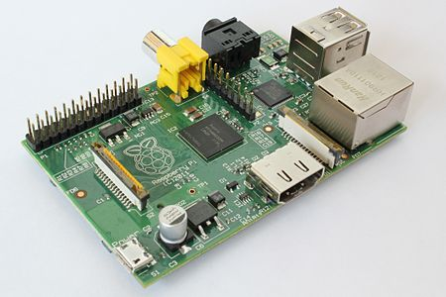
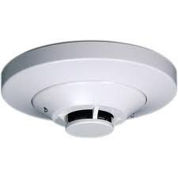
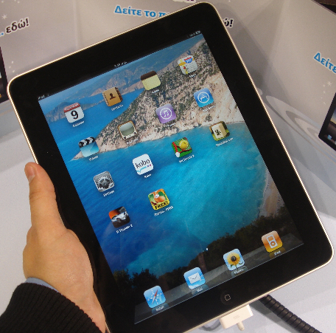
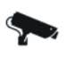
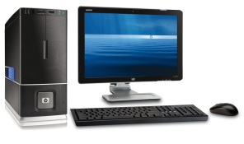
HeniHouse general design:
Raspberry PI
Sensors, camera etc.
Tablet
– anroid, ipad - Java
Web server (jetty, tomcat)
Alarm Control
servlet (java)
SQLite/MySQL/XML Database
Communication servlet
(java)
Scheduler servlet
(java)
UI web app (HTML5, Javascript)
Camera control servlet (java)

System setup and configuration

Alarm

Task
Monitor and evaluate status of the sensors; when problems detected (smoke, motion in area when locked etc.) raise alarm. When alarm is detected following actions can happen (configurable):
- Start siren (s)
- Send message over email
- Send SMS message
- Control defined device (switch lights on, start camera recording etc.)

Software alarm detection module runs on the RPI server.

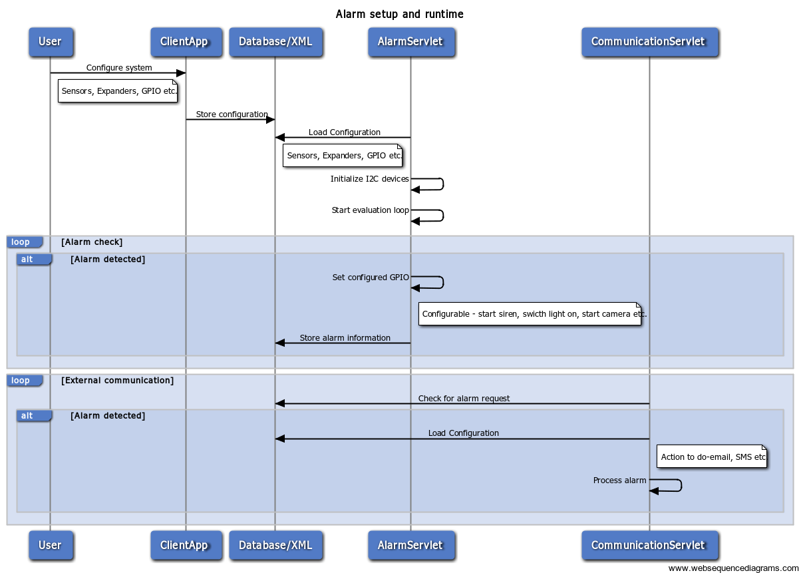

Supported devices
Following devices are supported by HeniHouse alarm module:
- Smoke detector
- Motion detector

Scheduler

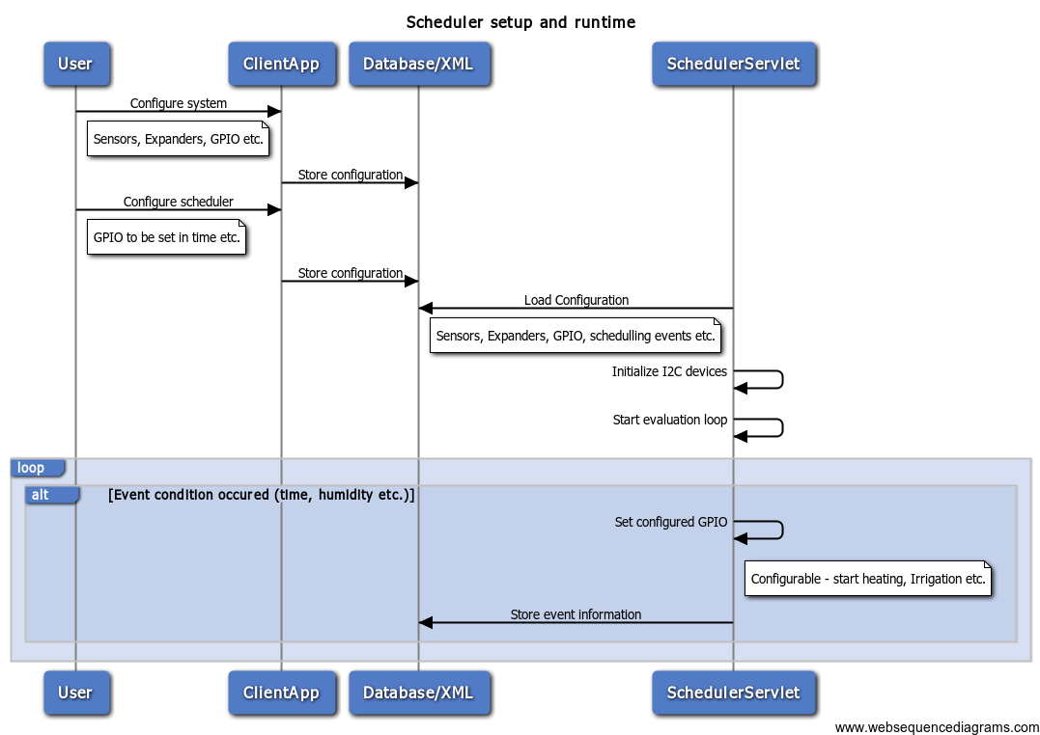

Database design

SQLite or MySQL database is used.

